Sunflower and Honeybee Health Summary

### Data

1. Outcome variables: honeybee health indicators

Varroa mites: number of varroa mites per 100 bees

Nosema parasite loads: Millions of spores of Nosema per bee

number of alive bees

Data source:

USDA Animal and Plant Health Inspection Services (APHIS) Survey of Honeybee Pests and Disease, containing the geographic coordinates of the apiaries.

429 apiaries in 33 states throughout the United States and year the sample was taken (2009 to 2015).

1. Sunflower acreage in a two-mile radius and a four-mile radius of apiaries

Data Source: the NASS Cropscape – Cropland data layer 2009-2015

1. Control variables:

Average minimum temperature in degrees Celsius during the collection month within 2 miles of the apiary from Oregon State University’s Prism database.

Precipitation in millimeters during the collection month within 2 miles of the apiary from Oregon State University’s Prism database.

Forage availability measured by Average NDVI (Normalized density vegetation index) during the month of the sample from the NASS Vegscape layers

### Methods

To estimate the degree of exposure to sunflower, we map the sampled non-migratory apiaries in APHIS onto NASS cropscape data to determine the crops grown within a two-mile radius of each apiary. To control for the timing of exposure to nearby sunflowers, we collect information on the time of planting (mid-April to late May) and blooming for sunflowers (during summer and a portion of fall).

The resolution of these data is set at 30 meters squared per pixel (USDA NASS n.d.). We extract the crop area within two miles of each apiary as this is vicinity in which bees typically do most of their foraging (Eckert, 1933). Therefore, this two-mile area, which comprises over 8,000 acres, provides the best estimate of the crops and landscape that bees would interact with during their foraging. We then calculate the percentage of the two-mile buffer area occupied by sunflower with the assumption that a linear relationship exists between changes in treated crop area and morbidity loads. We also use a four-mile buffer as a robustness check to see if we can get consistent results on the effect of having more sunflower acreages nearby.

We start by exploring the correlation between sunflower and honeybee pests. We compare colonies located near sunflowers to those further away, during planting, blooming versus other times of year. We also plan to take into account the biology, honeybee educators, honeybee patterns.

### Maps

1. Sunflower growing area map



Map of sunflower growing area (acres in a two-mile radius)

Growing states: centered around South Dakota and North Dakota.

states with acres less than 100 acres: Pennsylvania, New Jersey, California, Washington, Wisconsin, Arkansas, Virginia, Texas, Michigan

1. Maps for Varroa mites and Nosema parasites for non-migratory apiaries with pollen results.



Map of Mites Per 100 Bees



Map of Nosema load per Bee (in millions)

#### Summary Statistics

Out of a total of 743 observations over the two years (2014-2015), 72 observations in our data have sunflower within the 8000 acres area. 60 of them greater than 900 square meters .

More than half of the observations with large sunflower acreage (33 out of 60) are during July to October when there is possible sunflower blossom. 5 of them are between April to May when it is the planting season of sunflowers. Others are during November and February.

group 0 is no sunflower, group 1 is at least 900 square meters sunflower acreage within the 2 miles radius.

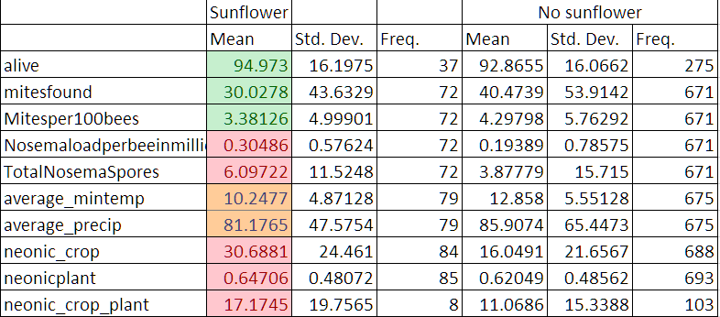

summary table for sunflower vs no sunflower grown nearby

### Correlation

## corrplot 0.84 loaded

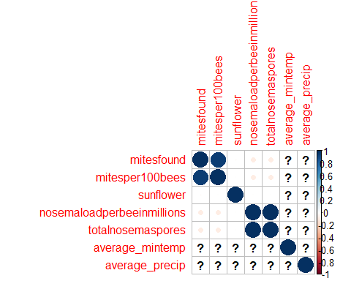

#### Regression

We ran some initial regressions on all of the three outcome variables: number of bees alive, mites found and nosema load. Controlling for month fixed effect, average temperature and precipitation, we regressed the bee health variables on both the sunflower growing area and two above-cutoff dummy (900 square meters or 1 acres).

In general, the effect of sunflower on bee health is somewhat suggestive but not very strong. Using a cut off dummy, areas where more sunflowers are grown, have 27 less mites on average. Similarly, increase one square meters of sunflower in nearby area contributes to 0.41 less mites on average.

Similar result can be found for the number of bees alive but the number alive results are not statistically significant. The effects on Nosema parasite is rather negligible.